**LAB 3 (Gates and Circuits)**

1. Complete the following questions from "Lab 6 Logic Circuits" (Lab6_Manual.pdf):

a. Exercise 1

1.) Open the Logic Gates App.

2.) Screenshot of the circuit:

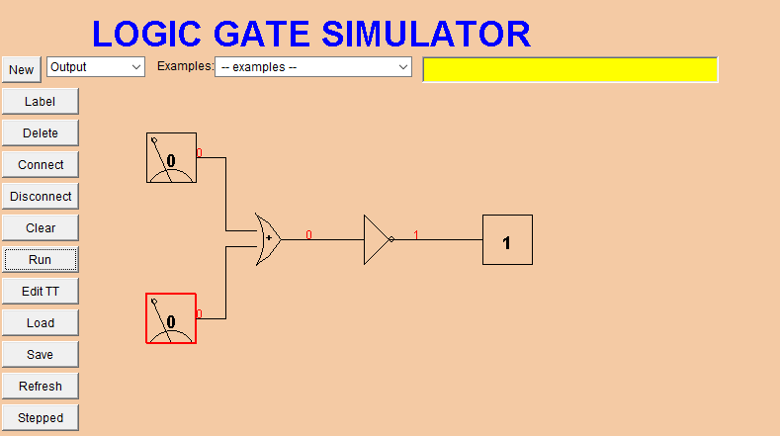

3.) Press run and try out all the combinations of inputs recording the results in a truth table.

Ans:

|  |  |  |
| --- | --- | --- |
| A | B | Output |
| 0 | 0 | 1 |
| 1 | 0 | 0 |
| 0 | 1 | 0 |
| 1 | 1 | 0 |

b. Exercise 2

1. Open the app
2. Draw the switches, AND gates and an output. Take a screenshot.

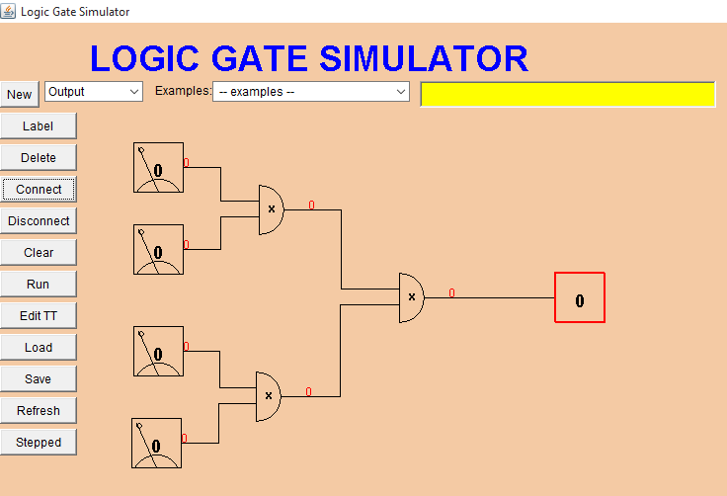

1. Write how many combinations you make from 4 switches. Can you explain your reason for this.

Ans: We can make 16 combinations by using 4 switches. The formula for calculating the number of combinations is:

Number of combinations = 2Total number of switches = 24 = 16

1. Click on run button and write the final output in a truth table.

|  |  |  |  |  |
| --- | --- | --- | --- | --- |
| A | B | C | D | Output |
| 0 | 0 | 0 | 0 | 0 |
| 0 | 1 | 0 | 0 | 0 |
| 0 | 0 | 1 | 0 | 0 |
| 0 | 0 | 0 | 1 | 0 |
| 1 | 0 | 0 | 0 | 0 |
| 1 | 1 | 0 | 0 | 0 |
| 1 | 0 | 1 | 0 | 0 |
| 1 | 0 | 0 | 1 | 0 |
| 1 | 1 | 1 | 0 | 0 |
| 1 | 1 | 1 | 1 | 1 |
| 1 | 1 | 0 | 1 | 0 |
| 1 | 0 | 1 | 1 | 0 |
| 0 | 1 | 1 | 0 | 0 |
| 0 | 1 | 1 | 1 | 0 |
| 0 | 1 | 0 | 1 | 0 |
| 0 | 0 | 1 | 1 | 0 |

1. Your circuit utilizing three AND gates is equivalent to ............ .Does your truth table from the previous step bear this out?

Ans: Yes, The circuit of 3 AND gates do the same work as done by 1 huge AND gate. The Boolean expression for this also computes the same as for one huge AND gate and it is discussed as follows:

Final output = (1st AND gate).(2nd AND gate)

= (AB).(CD)

= A.B.C.D

= Product of all inputs = One huge AND gate

c. Exercise 3

1. Open the app
2. Label the switches and add 2 connectors, 2 AND gates ,1OR gate and an output.
3. After connecting, take a screenshot.

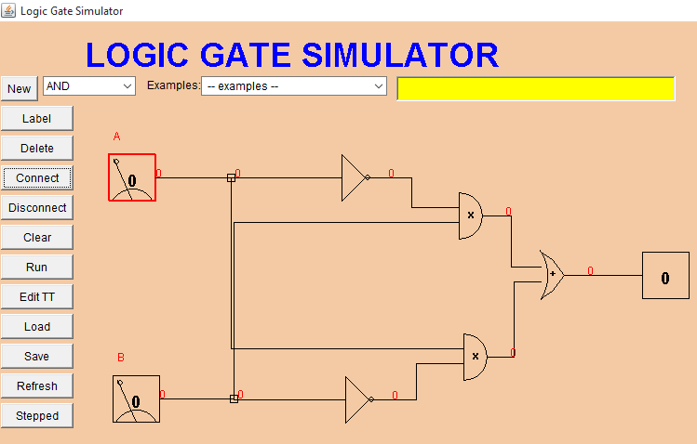

1. Press run and record the final output in a table.

|  |  |  |
| --- | --- | --- |
| A | B | Final Output |
| 0 | 0 | 0 |
| 1 | 0 | 1 |
| 0 | 1 | 1 |
| 1 | 1 | 0 |

1. This circuit does the same gate as one of the gates in the drop down menu of the app does. Which is the gate that gives the same output?

Ans: This circuit gives the same output as done by XOR Gate. This can be explained by comparing the truth tables of the final output of the circuit and the XOR gate with 2 inputs.

d. Exercise7

Screenshot of the circuit showing correct result:

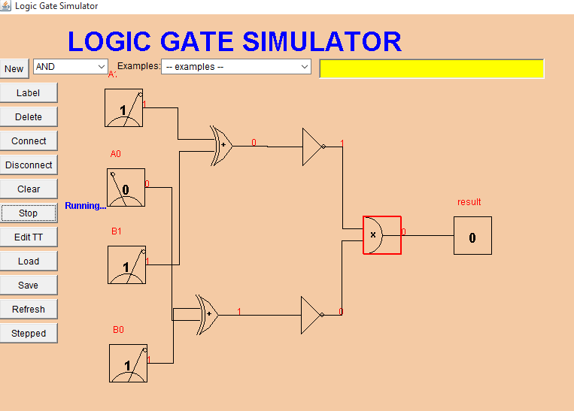

e. Exercise8

The two outputs are as follows :

|  |  |  |  |
| --- | --- | --- | --- |
| A | B | Top Output | Bottom Output |
| 0 | 0 | 1 | 1 |
| 0 | 1 | 1 | 1 |
| 1 | 0 | 1 | 1 |
| 1 | 1 | 0 | 0 |

The outputs are same and this proves the De Morgan’s law to be true. Also the picture of how the circuit looks like is below.

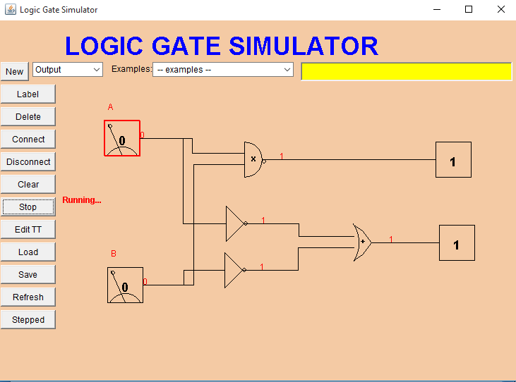

2. Given the following Boolean expression: X = (A'B + C)

a. Draw the circuit diagram for X (use the applet and insert a screen shot).

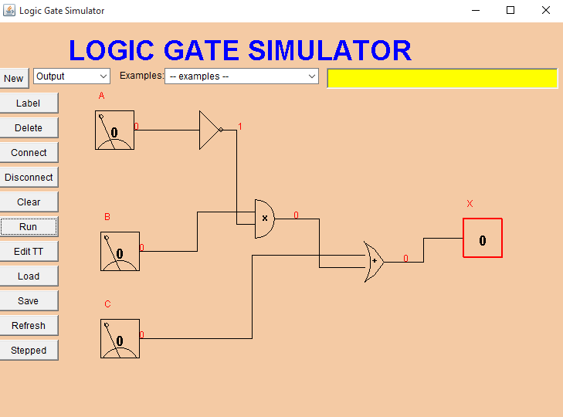

b. Write the truth table for X.

|  |  |  |  |
| --- | --- | --- | --- |
| A | B | C | X |
| 0 | 0 | 0 | 0 |
| 0 | 1 | 0 | 1 |
| 0 | 0 | 1 | 1 |
| 0 | 1 | 1 | 1 |
| 1 | 0 | 0 | 0 |
| 1 | 1 | 0 | 0 |
| 1 | 0 | 1 | 1 |
| 1 | 1 | 1 | 1 |

3. Given the following Boolean expression: Y = (AB' + BC) D

a. Draw the circuit diagram for Y (use the applet and insert a screen shot).

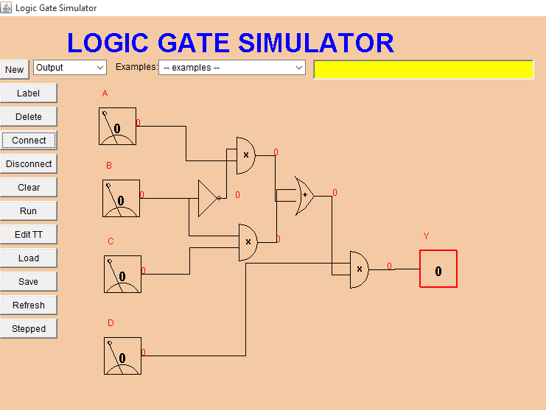

b. Write the truth table for Y.

|  |  |  |  |  |
| --- | --- | --- | --- | --- |
| A | B | C | D | Y |
| 0 | 0 | 0 | 0 | 0 |
| 0 | 1 | 0 | 0 | 0 |
| 0 | 0 | 1 | 0 | 0 |
| 0 | 0 | 0 | 1 | 0 |
| 0 | 1 | 1 | 0 | 0 |
| 0 | 0 | 1 | 1 | 0 |
| 0 | 1 | 0 | 1 | 0 |
| 1 | 1 | 0 | 0 | 0 |
| 1 | 0 | 1 | 0 | 0 |
| 1 | 0 | 0 | 1 | 1 |
| 1 | 0 | 1 | 1 | 1 |
| 1 | 1 | 1 | 0 | 0 |
| 1 | 1 | 0 | 1 | 0 |
| 1 | 0 | 0 | 0 | 0 |
| 0 | 1 | 1 | 1 | 1 |
| 1 | 1 | 1 | 1 | 1 |

4.Given the following logic diagram:

a. Write the Boolean expression for Q.

Ans: Q = A.B + (A+B)’

Q = A.B + A’B’ [Using De Morgan’s Law]

b. Write the truth table for intermediate values and Q

|  |  |  |  |  |  |  |
| --- | --- | --- | --- | --- | --- | --- |
| A | B | AND Gate | | NOR Gate | | Q |
| 0 | 0 | 0 | | 1 | | 1 |
| 1 | 0 | 0 | | 0 | | 0 |
| 0 | 1 | 0 | | 0 | | 0 |
| 1 | 1 | | 1 | | 0 | 1 | |

5. Given the following circuit diagram:

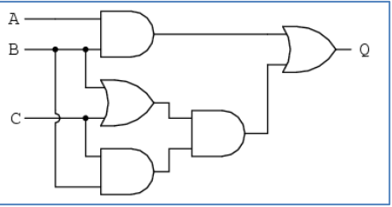

1. Write a Boolean expression for Q.

Ans: Q = A.B + ((B+C).(B.C))

= A.B + (B.B.C + C.B.C

= A.B + B.C + C.B

= A.B+ B.C + B.C

= A.B + B.C

Q = B(A+C)

1. Write the truth table for intermediate outputs (4 of them) and Q.

Ans:

|  |  |  |  |  |  |  |  |
| --- | --- | --- | --- | --- | --- | --- | --- |
| A | B | C | TOP AND | OR | BOTTOM AND | AND | Q |
| 0 | 0 | 0 | 0 | 0 | 0 | 0 | 0 |
| 0 | 1 | 0 | 0 | 1 | 0 | 0 | 0 |
| 0 | 0 | 1 | 0 | 1 | 0 | 0 | 0 |
| 0 | 1 | 1 | 0 | 1 | 1 | 1 | 1 |
| 1 | 0 | 0 | 0 | 0 | 0 | 0 | 0 |
| 1 | 1 | 0 | 1 | 1 | 0 | 0 | 1 |
| 1 | 0 | 1 | 0 | 1 | 0 | 0 | 0 |
| 1 | 1 | 1 | 1 | 1 | 1 | 1 | 1 |

6. Using properties of Boolean algebra, simplify the following Boolean expressions so they could be built with the minimum number of gates.

a. X = A + BC + AB + ABC + B

X = A + AB + ABC +BC + B

= A(1+A) + ABC + B(C+1)

= AA + ABC + BC

= A + BC(A+1)

= A + BCA

= A(BC+1)

X = ABC

b.Y = AB + B(AC + BC + ABC' + A)

Y = AB + ABC + BBC + BABC’ + BA

= AB + BA + ABC + BC + ABC’

= AB + BC(A+1) + ABC’

= AB + ABC + ABC’

= AB(1+C) + ABC’

= ABC + ABC’

= AB(C+C’)

Y = AB

c.W = ABC' + AB'C' + B'CD + A'C + BC

W = AC’(B+B’) + B’CD + A’C + BC

= AC’ + B’CD + A’C + BC

= AC + (B’D + A’ +B)C

W = C(A + B’D +A’ + B)

d.Z = (A + B')' + (ABC')' + A(B + A'C)'

Z = A’.B + A’ + B’ + C + A(B’.(A’C)’)

= A’( B+1 ) + B’ + C + AB’(A +C’)

= A’B + B’ + C + AB’A + AB’C’

= A’B + B’+ C + AB’ + AB’C’

= A’B +B’(1+A) + C + AB’C’

= AB’ + AB’ + C + AB’C’

= AB’ + C + AB’C’

= AB’(1+C’) + C

Z = AB’C’ +C

7. Given the following Boolean expression: W = A'B + B'C + CB + ABC'

a. Simplify the expression as much as possible using the properties of Boolean algebra so it could be built with the minimum number of gates.

W = A’B +B’C + CB + ABC’

= A’B + C(B’+ B) + ABC’

W = A’B + C + ABC’

b. Create the truth table for W and create the truth table for the simplified expression (this will validate your simplified expression).

ANS: The truth table for W:

|  |  |  |  |
| --- | --- | --- | --- |
| A | B | C | W |
| 0 | 0 | 0 | 0 |
| 0 | 1 | 0 | 1 |
| 0 | 0 | 1 | 1 |
| 0 | 1 | 1 | 1 |
| 1 | 0 | 0 | 0 |
| 1 | 1 | 0 | 1 |
| 1 | 0 | 1 | 1 |
| 1 | 1 | 1 | 1 |

Truth table for the simplified output:

|  |  |  |  |
| --- | --- | --- | --- |
| A | B | C | Simplified W |
| 0 | 0 | 0 | 0 |
| 0 | 1 | 0 | 1 |
| 0 | 0 | 1 | 1 |
| 0 | 1 | 1 | 1 |
| 1 | 0 | 0 | 0 |
| 1 | 1 | 0 | 1 |
| 1 | 0 | 1 | 1 |
| 1 | 1 | 1 | 1 |

The output for both is same.

8. Given the following truth table, write the Boolean expressions for X and Y (they are two separate outputs) in terms of A, B, and C, simplify them, and draw the logic diagram for the simplified expression (use the applet and insert a screen shot).

|  |  |  |  |  |
| --- | --- | --- | --- | --- |
| A | B | C | X | Y |
| 0 | 0 | 0 | 0 | 1 |
| 0 | 0 | 1 | 1 | 0 |
| 0 | 1 | 0 | 1 | 1 |
| 0 | 1 | 1 | 0 | 0 |
| 1 | 0 | 0 | 1 | 1 |
| 1 | 0 | 1 | 1 | 0 |
| 1 | 1 | 0 | 1 | 1 |
| 1 | 1 | 1 | 0 | 1 |

ANS: Boolean Expression for X:

X = A’B’C + A’BC’ + AB’C’ + AB’C + ABC’

= (A’+A)B’C + (A’+A)BC’ + AB’C’

X = B’C +BC’ + AB’C’

Logic diagram for X: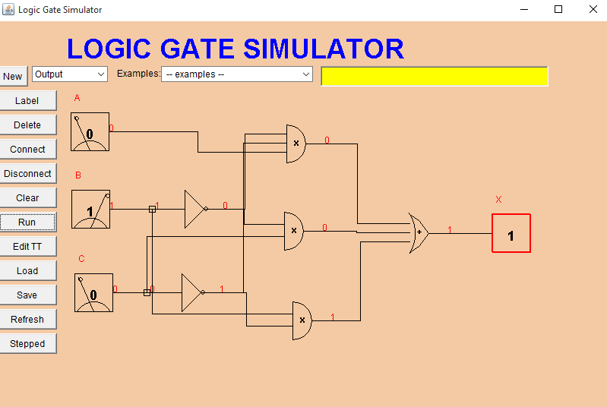

Boolean Expression for Y:

Y = A’B’C’ + A’BC’ + AB’C’ + AB’C + ABC’ + ABC

= A’C’(B’ + B) + AB’(C’+C) + AB(C’+C)

= A’C’ + AB’ +AB

= A’C’ + A(B’+B)

Y = A’C’ + A

Logic diagram for Y :

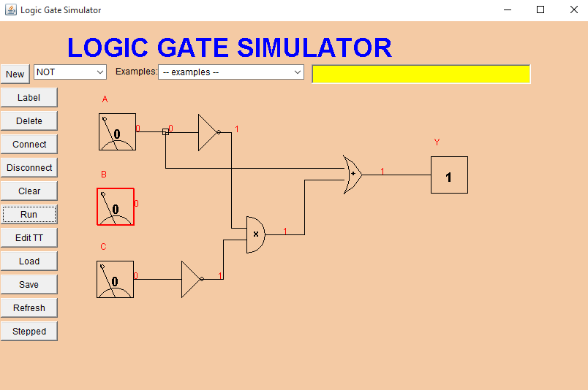

Logic diagram for Y